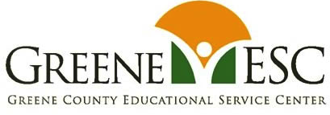
Business Advisory Council (BAC)
December 12, 2019, 9:30 AM at Greene County ESC, Board Conference Room
Attendees: Pat Phipps, Clancy Cross, Lee Snell, Alice Wiseman, Chip Arledge, Terry Graves-Strieter
Greene County BAC Mission Statement: The Greene County Business Advisory Council, in partnership with Greene County schools and businesses, will assist in the assessment of workforce needs and employability skills for student success in the regional economy.
- Review Plan for 2019-20 School Year
Plan for school year was reviewd.

- Review minutes October 9, 2019 Meeting
Minutes from October 9th meeting were reviewed.

- Project LIFE – update
Report given. The development team is working with WSU on securing a space for the program. Sponsorship of the program was discussed. Discussion on writing to specific business(es) about this concept. Superintendent Strieter said she would do this prior to next BAC meeting.

- DRMA updates-
DRMA is offering “Power Lunches” at the Greene County districts. Any district wanting to set these up should contact Angelia Erbaugh, President of the Dayton Region Manufacturing Association, aerbaugh@daytonrma.org

- Upcoming meeting – status of partnerships in districts
Determine partnerships at each district—in existence, in progress, or not at all.
Letter to business(es) for possible partnerships for HS students. See above in #3.

- Career Path Less Taken—Video, view on own
Each BAC Member is encouraged to view this video on own time. Each district’s board members are also encouraged to view video. (Video link is now on the GCESC BAC website..)

- Next Meeting: FEBRUARY 12, 2020 at 9 AM in GCESC COMMONS, Full Council

Mark your calendars for meetings this school year:
February 12, 2020, 9 AM, Full Council
June 11, 2020, 9:30 AM (within GCESC Board Meeting)
Thank you for being a part of this group!

